SPRINT – 3

|  |  |
| --- | --- |
| **Team ID** | **PNT2022TMID36755** |
| **Project Name** | **Project - IOT based smart crop**  **protection for agriculture** |
| **Maximum Marks** | **20 Marks** |

STEP 1: MIT APP inventor to design the APP.

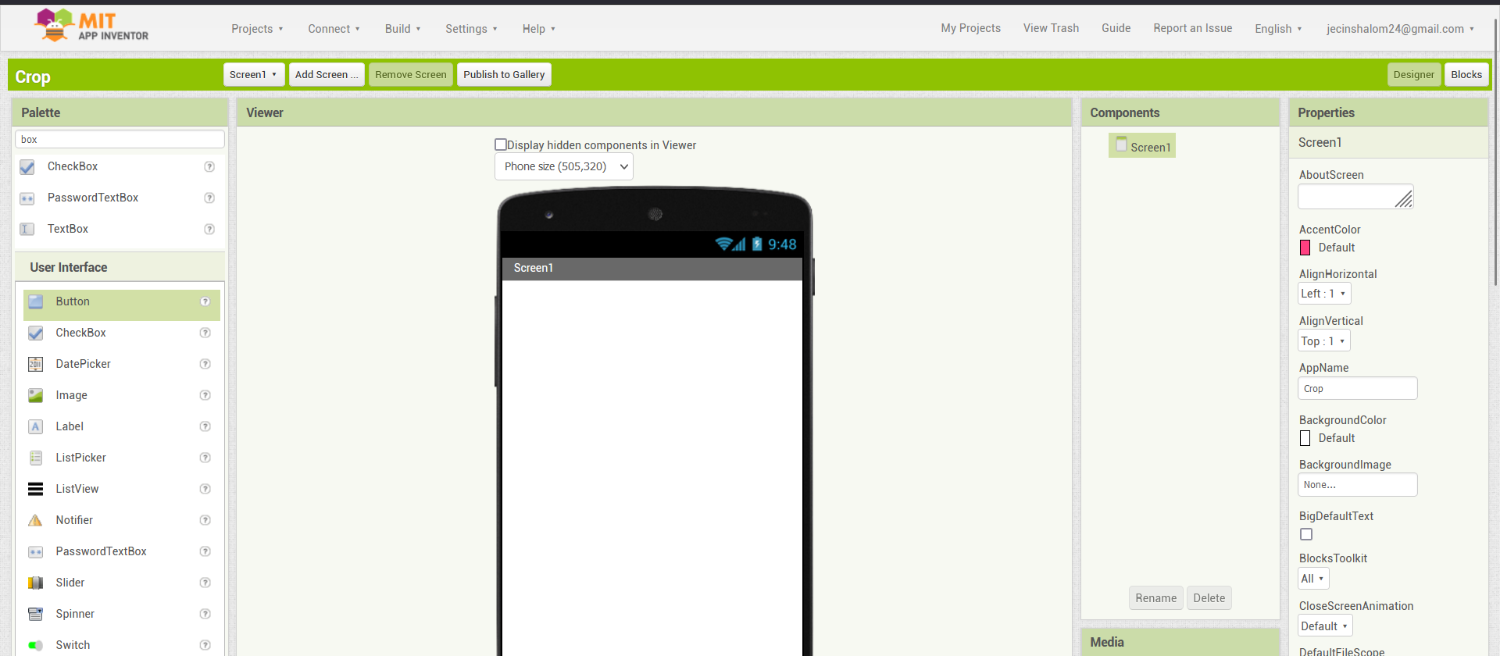

STEP 2: Customize the App interface to Display the Values.

